# Homework 9: Think-Aloud *Recordings*

## **Lydia Stamato & Manu Peethambar**

HCC 729: Human-Centered Design

April 14, 2019

## Participant 1

**Audio recording:**

<https://drive.google.com/open?id=1JzH7Ym4kGCJ-BCkODd7Ot8QQSl7JYfgE>

**Participant-Prototype interaction photos:**

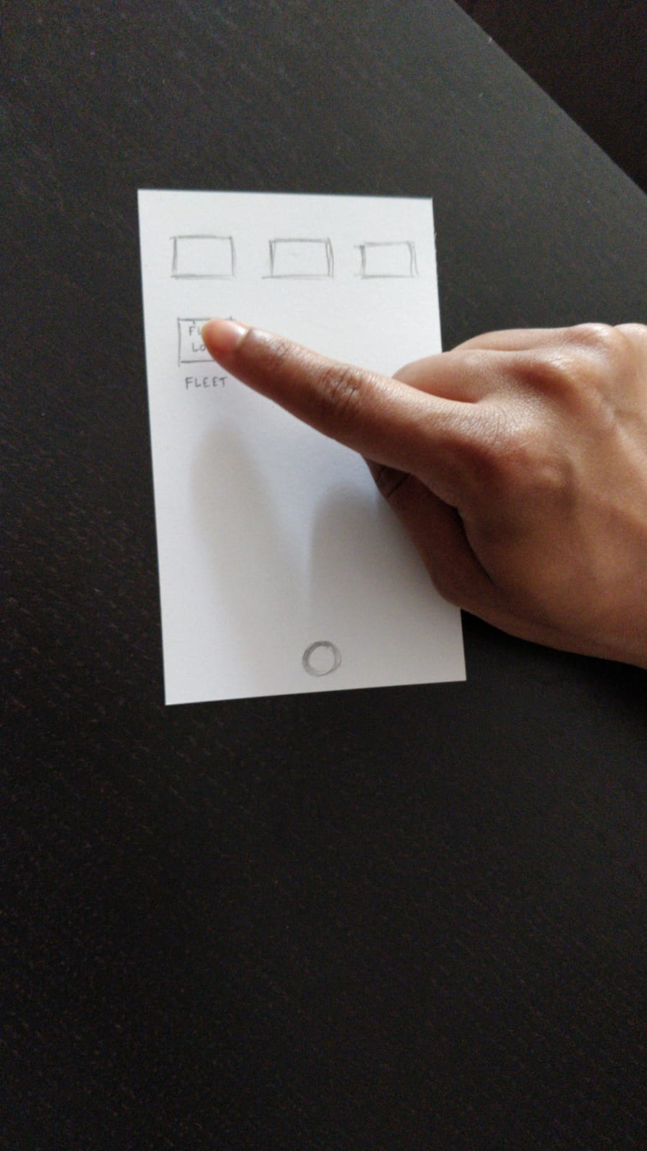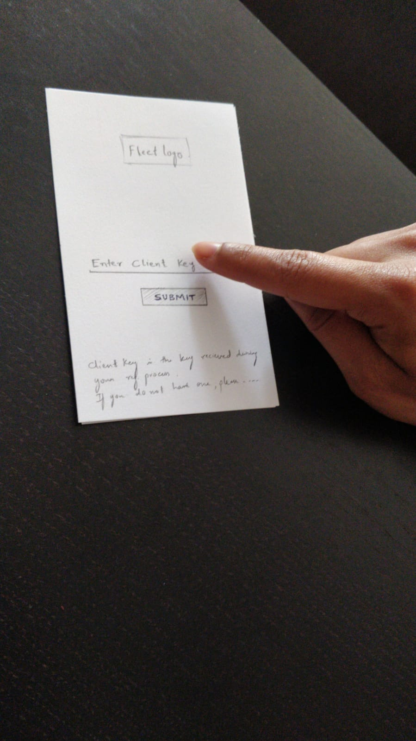

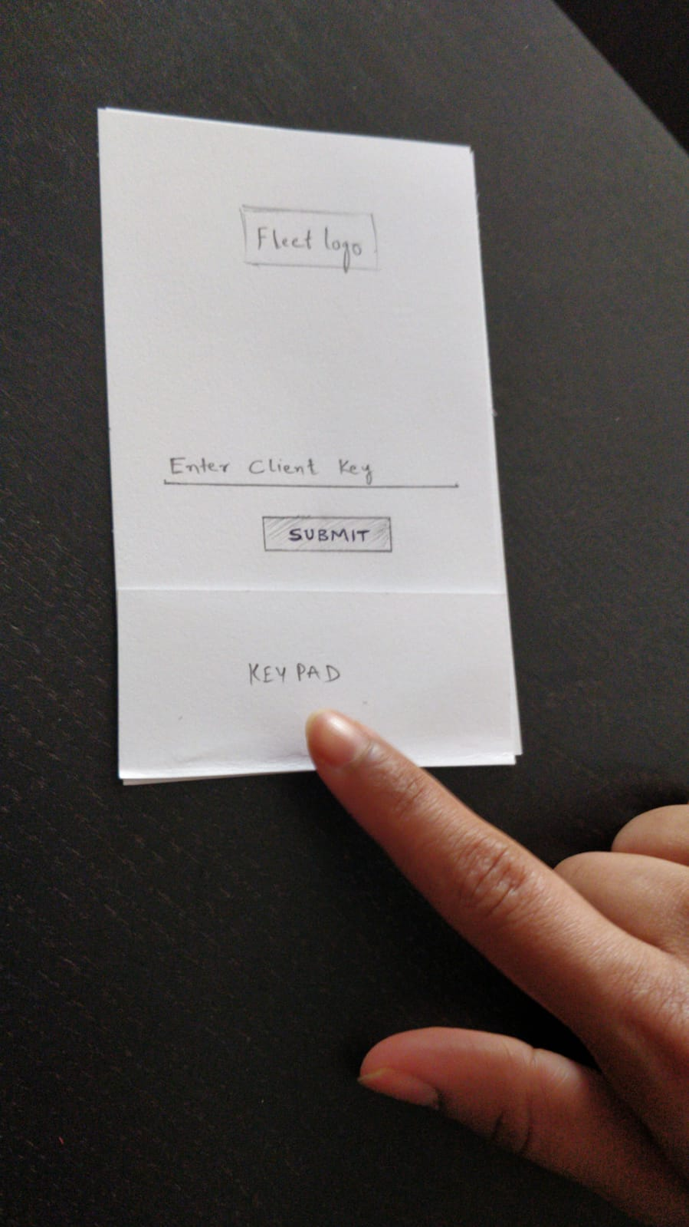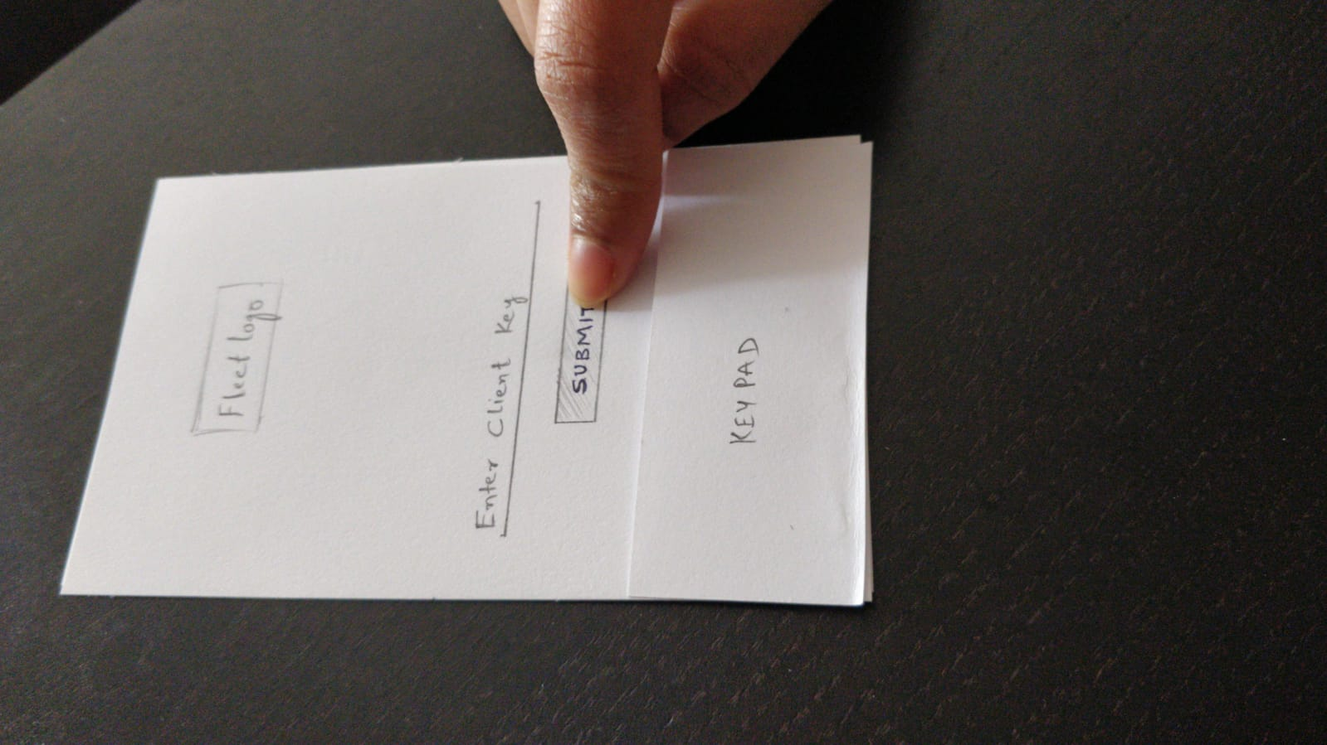

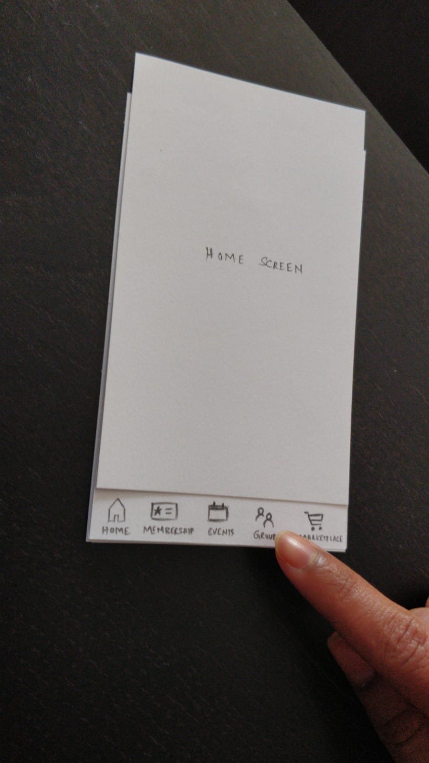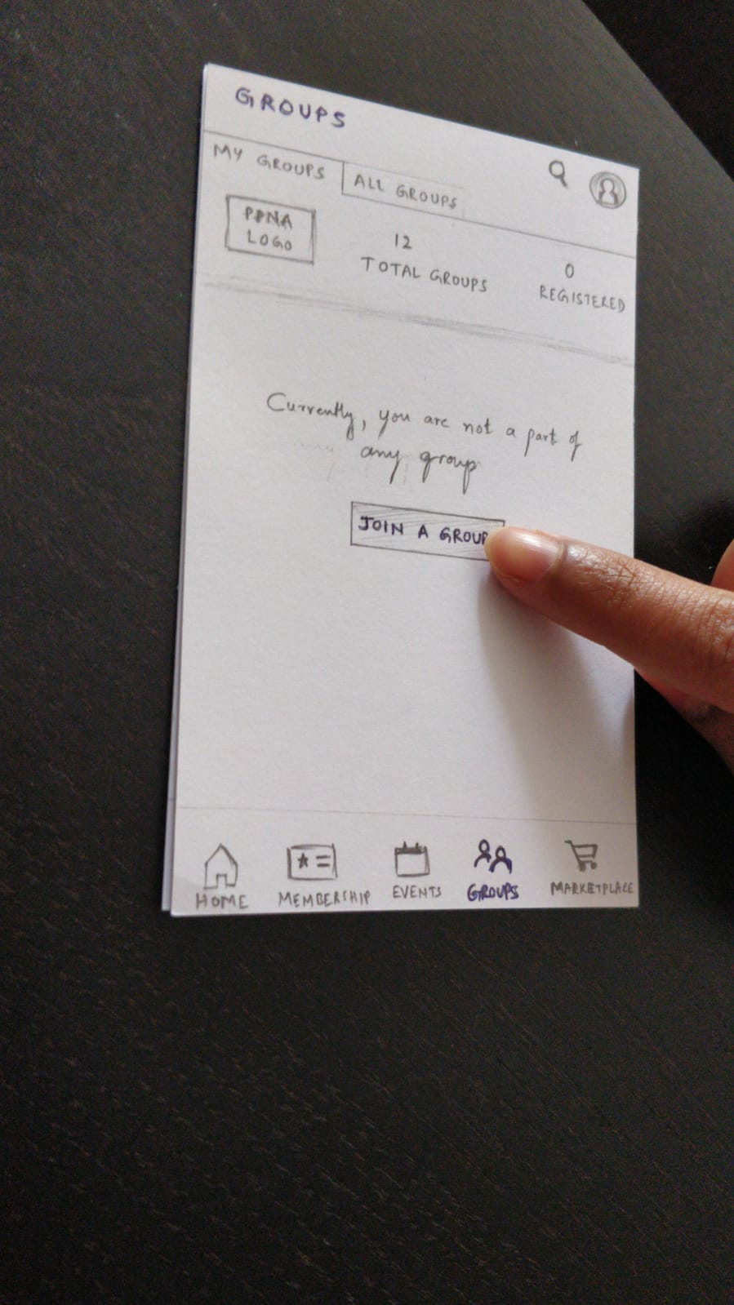

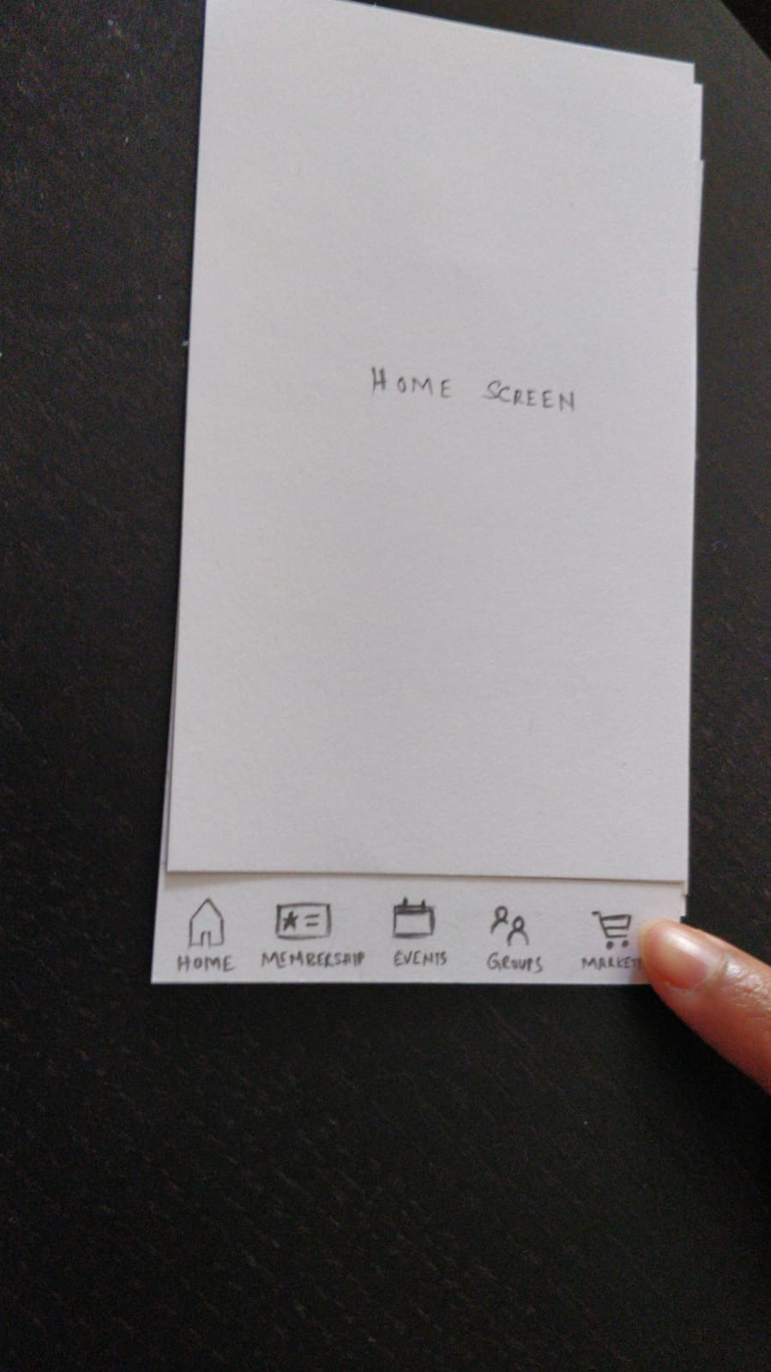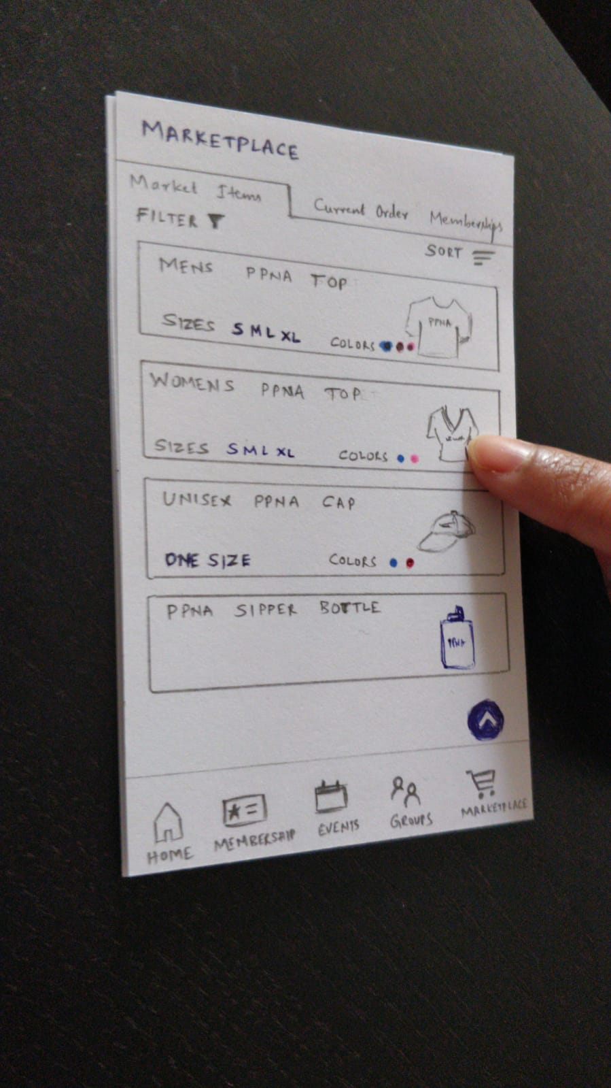

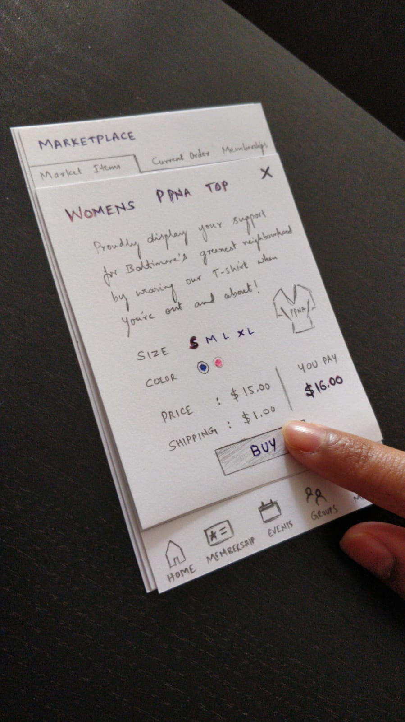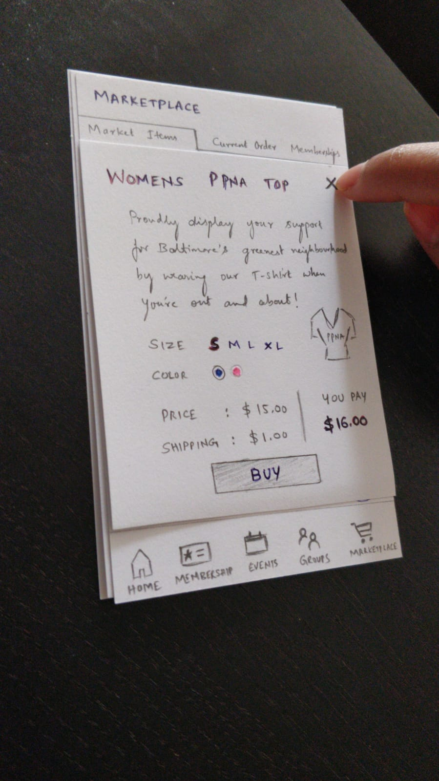

## Participant 2

**Audio recordings:**

* Part 1: <https://umbc.box.com/s/w6dyapk3gxgcxlvu9e10x0ziukyvo8f0>
* Part 2: <https://umbc.box.com/s/6owbb3qisl26h9hflffuttp8mlxshxh2>

**Screen recordings:**

* Part 1: <https://drive.google.com/open?id=1LhmBVTCyQcJvaXXA2Et2YHBO0HAQJ2Gk>
* Part 2:

<https://drive.google.com/file/d/1hw0t6Yik9MRyNcX1GMg_0BMppZf0AWOX/view?usp=sharing>